Report

Laboratory work 1

“Bridges searching algorithms and comparison depending on type of sorting”

Aroslankin, Smolnikova

Report plan:

Graph structure which was used

Generating random graph models

Deterministic bridges searching with DFS

Randomized bridges searching

1. The mistake probability

Comparison between deterministic and randomized search

Randomized 2-bridges searching

1. The mistake probability

2. Used sorts

1. bucket sort
2. std::sort
3. radix sort

3. Sorts comparison

Test of real graph dataset

Graph structure - CSR (Compressed Sparse Rows)

CSR format, globally, is a special storage type for huge sparse matrix, where almost all elements are zero.

In graph case, we store adjacency matrix in CSR. It is very popular format to store graphs in commercial companies who have a lot of graph type data to analyze.

The general idea of this format can be revealed by the picture below.

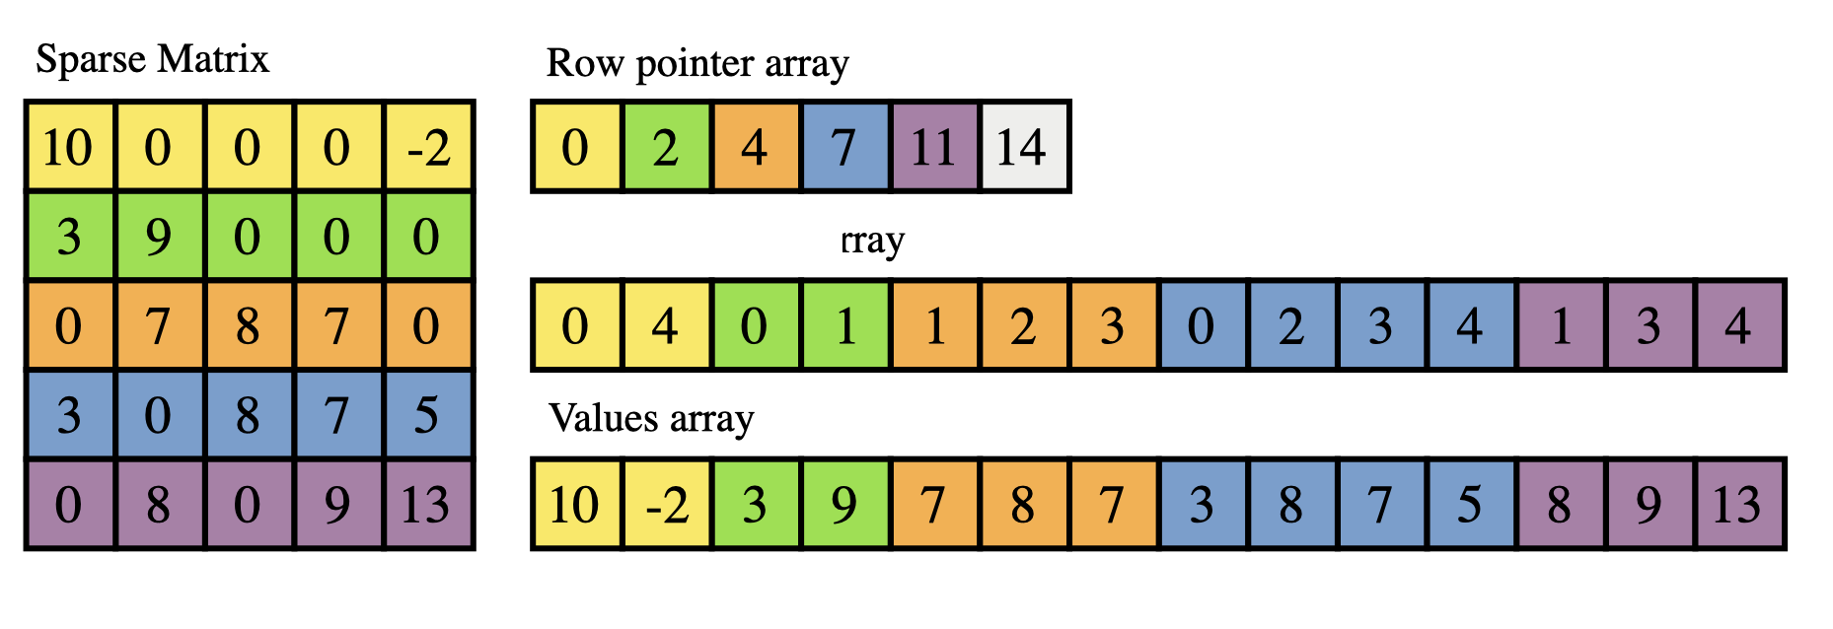

What we have in graph case:

1. O(1) access to degree of any vertex.
2. The same memory as for adjacency list.
3. O(search in sorted list) to find neighbor.
4. All memory is nearby and can be easy aligned. So there no redirection costs. As a result, higher memory bandwidth for performance optimization.

Our implementation of CSRgraph class is in “graph.h” file.

Generating random graph models

As a random model to test on we took Erdos-Renyi random graph model.

Random model has two parameters:

1. Number of vertices
2. Probability of creating an edge between any two vertices(except selfloops).

We use- std::mt19937 random device generator and std::bernoulli_distribution for probability of creating an edge.

Our implementation of create_graph function is in “graph.h” file.

**Deterministic bridges searching with DFS**

The main idea of this algorithm:

Let's say we are in the DFS, looking through the edges starting from vertex v. The current edge (v,u) is a bridge if and only if none of the vertices u and its descendants in the DFS traversal tree has a back-edge to vertex v or any of its ancestors. Indeed, this condition means that there is no other way from v to u except for edge (v,u). We will use "time of entry into vertex" computed by the depth first search to check bridge for each vertex efficiently.

The implementation needs to distinguish three cases: when we go down the edge in DFS tree, when we find a back edge to an ancestor of the vertex and when we return to a parent of the vertex.

Time complexity O(|V| + |E|).

Our implementation of dfs_bridges is in “algorithms.h” file.

**Randomized bridges searching**

**The mistake probability**

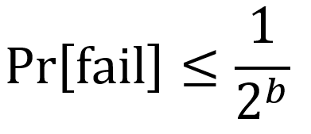

, there b is number of bits

We considered uint32 and uint64 mistakes probability, p_in for graph generating 0,001:

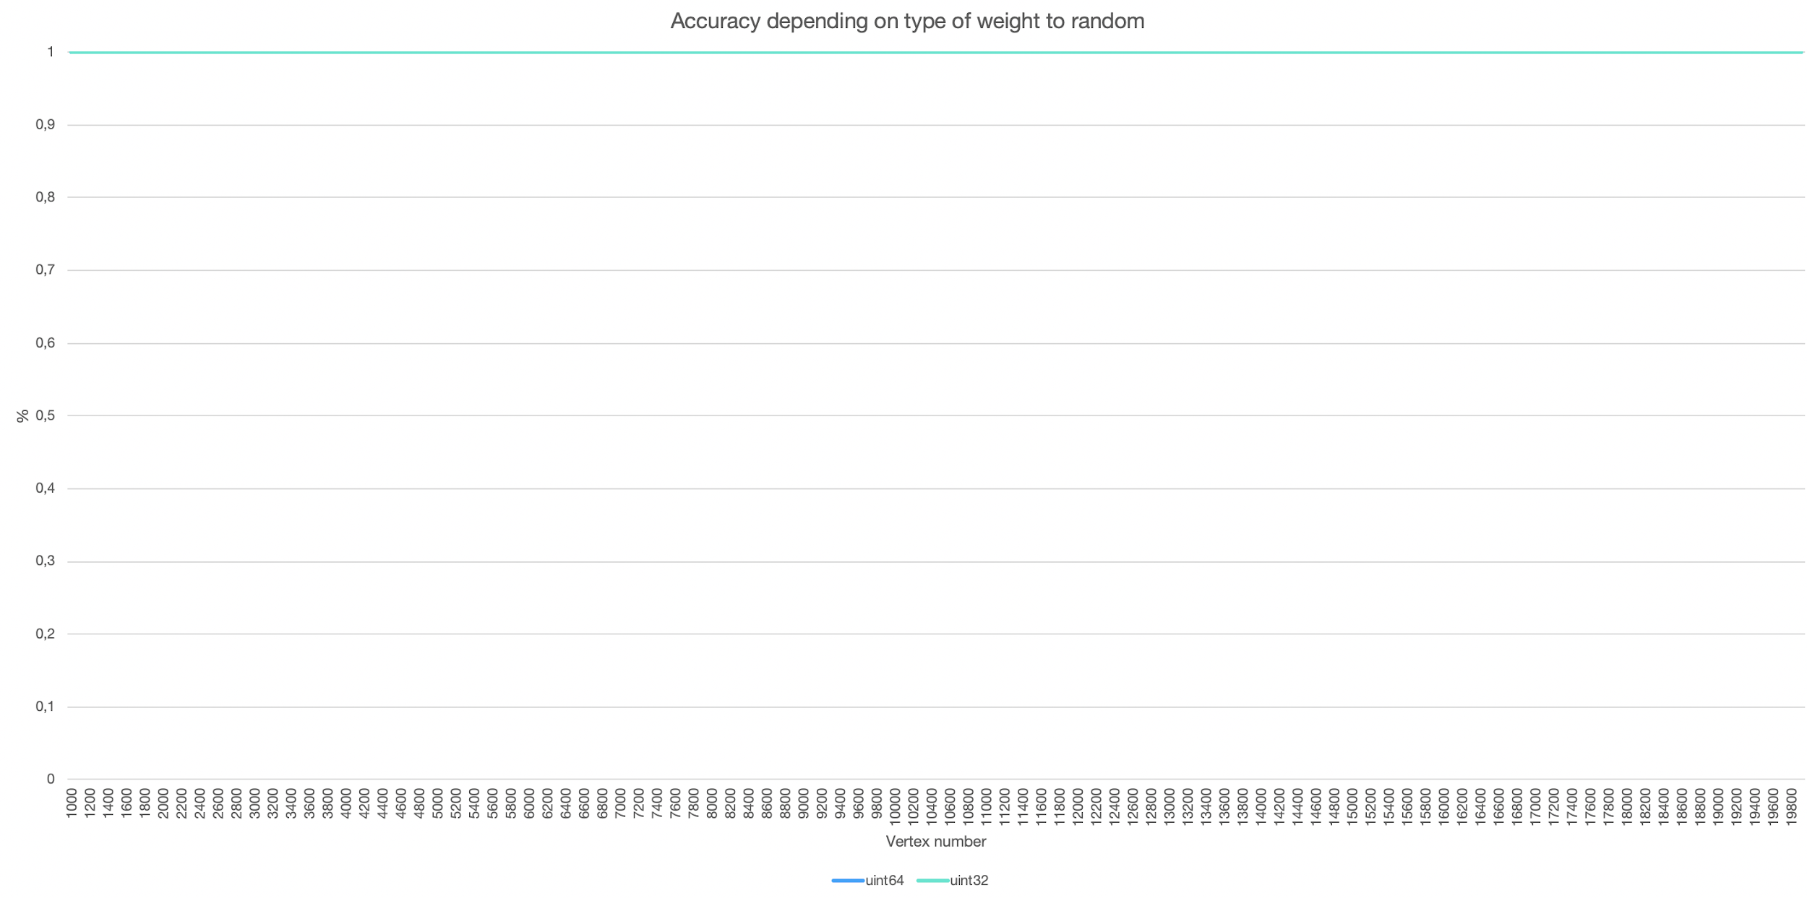

uint32 and uint64 random based algorithms have been passed all verification tests.

We considered uint8 and uint16 mistakes probability, p_in for graph generating 0,001:

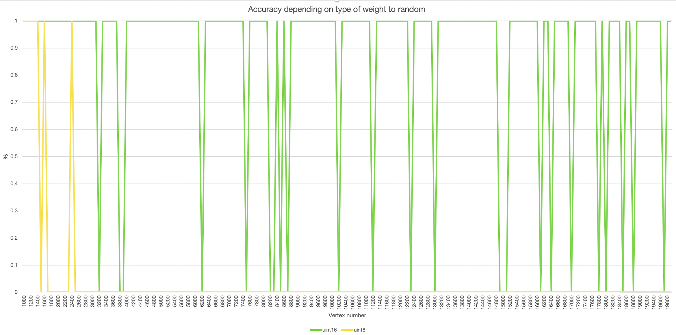

With uint8 we are getting error very early.

**Comparison between deterministic and randomized searching**

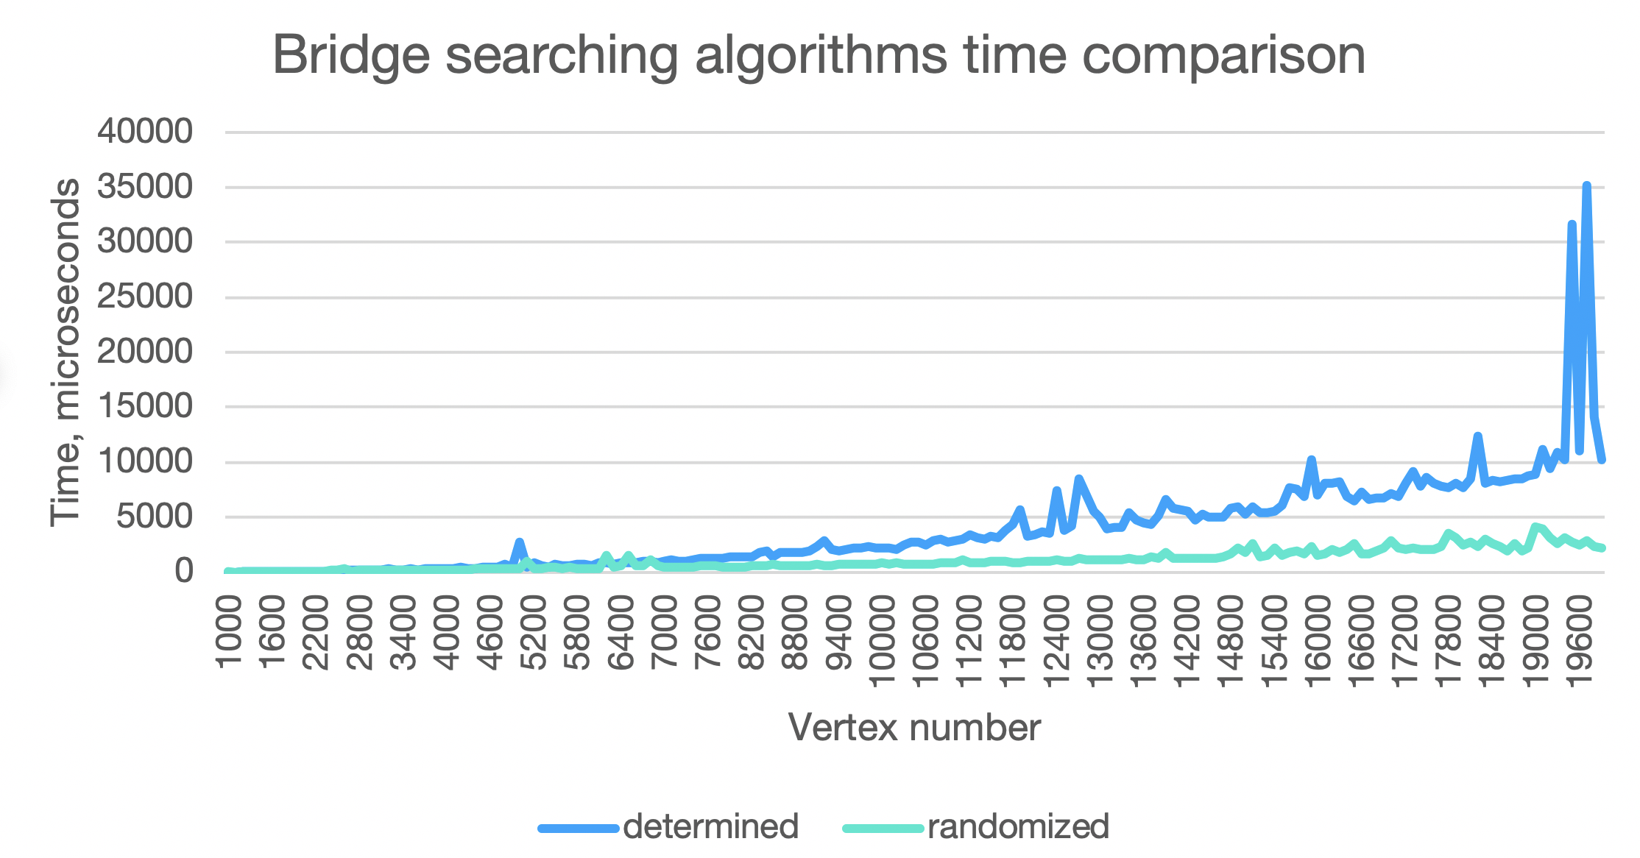

**Randomized 2-bridges searching**

Our implementation is based on <https://arxiv.org/abs/cs/0702113> .

The sources are in “algorithms.h”. There is a one parent class randomized_dfs_init which was introduced with purpose of reducing code duplication of two similar algorithms 1 and 2 bridges searching.

**The mistake probability**

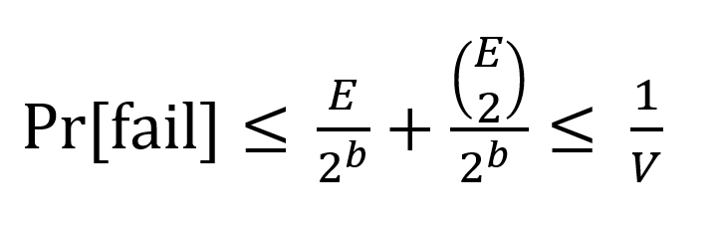

, there E - number of edges

V - number of vertex

b - number of bits

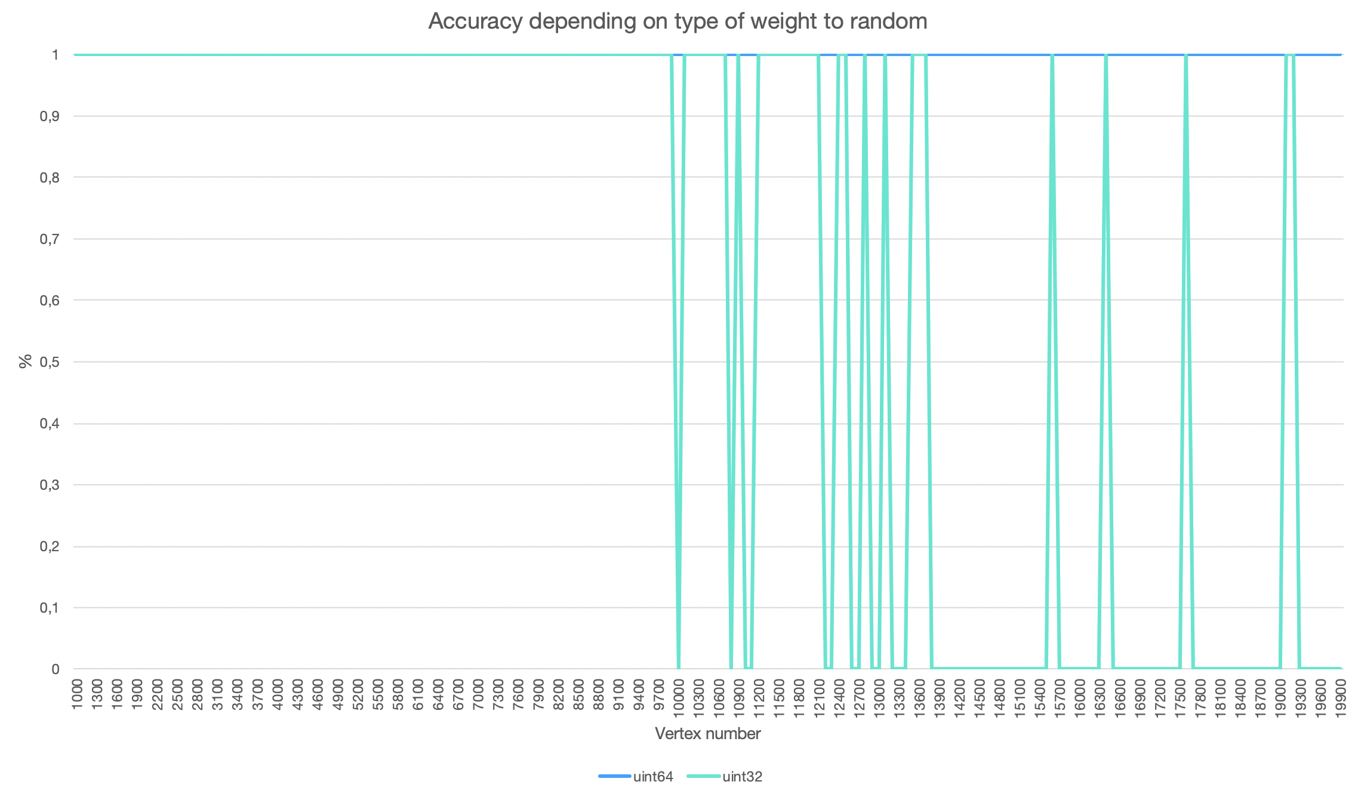

With 64 bits weights for random randomized algorithm passed all verification tests, where number of vertices from 1000 to 20000 and probability is 0,01. With 32 bits weights starting from 10000 some errors are occurred.

**Used sorts**

3D surfaces graphs below provide us information dependency from both parameters probability and number of vertices for corresponding generated graph. It can be revealed that time complexity is almost linear from probability and square from number of vertices. It is worth noting that parameter probability proportional to number of edges. So we can say that we have linear complexity from edges number.

P.S. There are some noise peaks at surfaces. Performance measurements are not 100% clear because other applications work etc. The solution was found to make more than 10 time measurements for any parameter value and take median time or box filter.

**1. Bucket sort**

Bucket sort works by distributing the elements of an array into a number of buckets. Each bucket is then sorted individually, using a count sorting algorithm.

Expected complexity O(E)

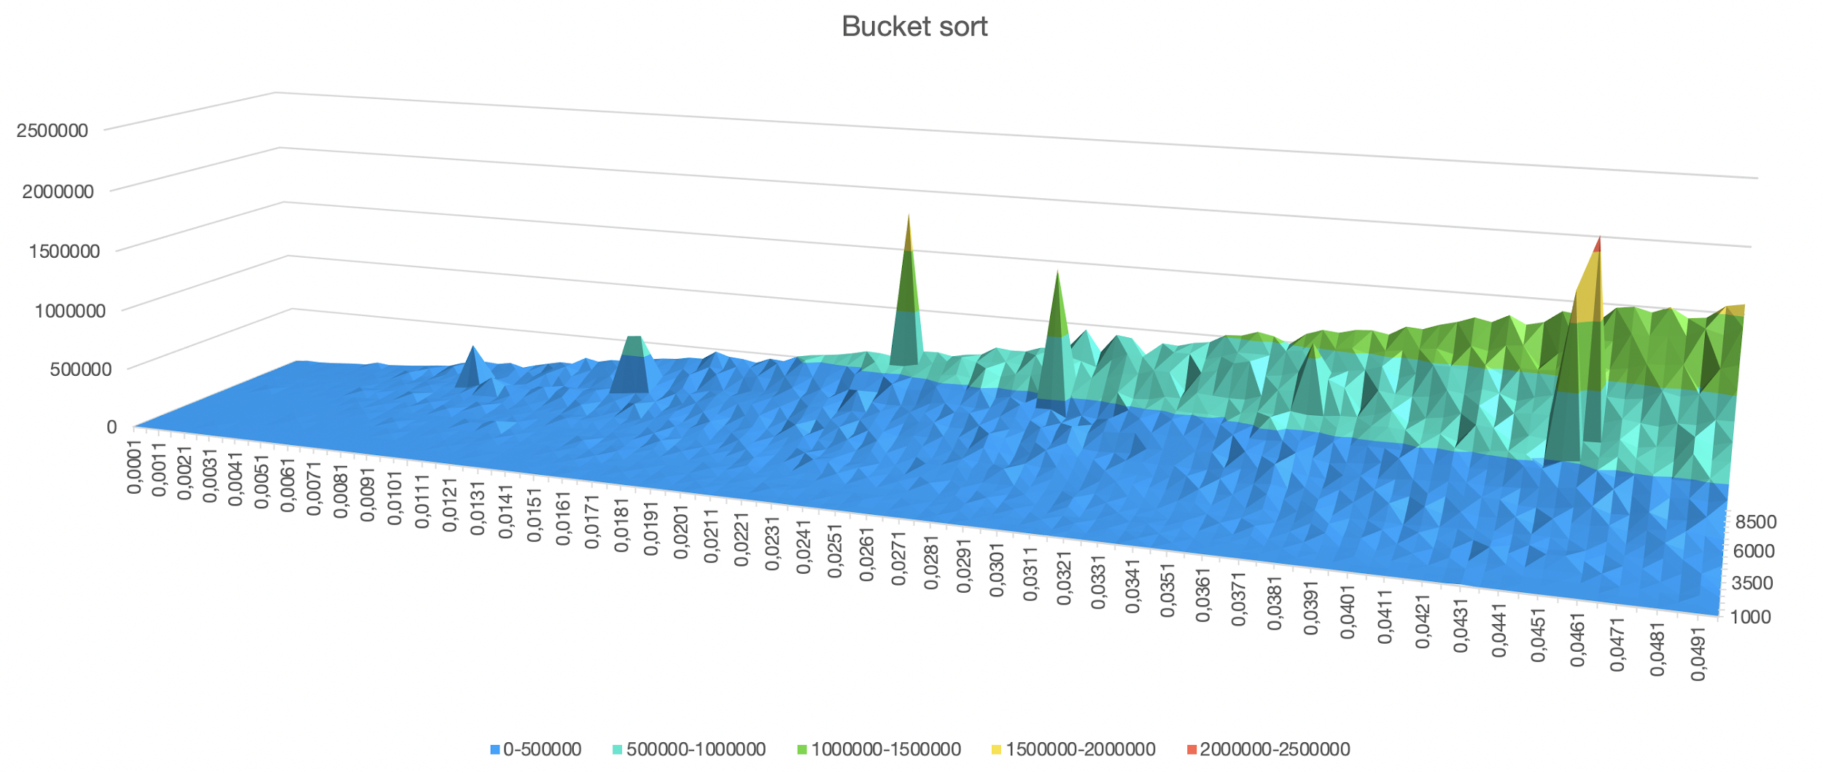

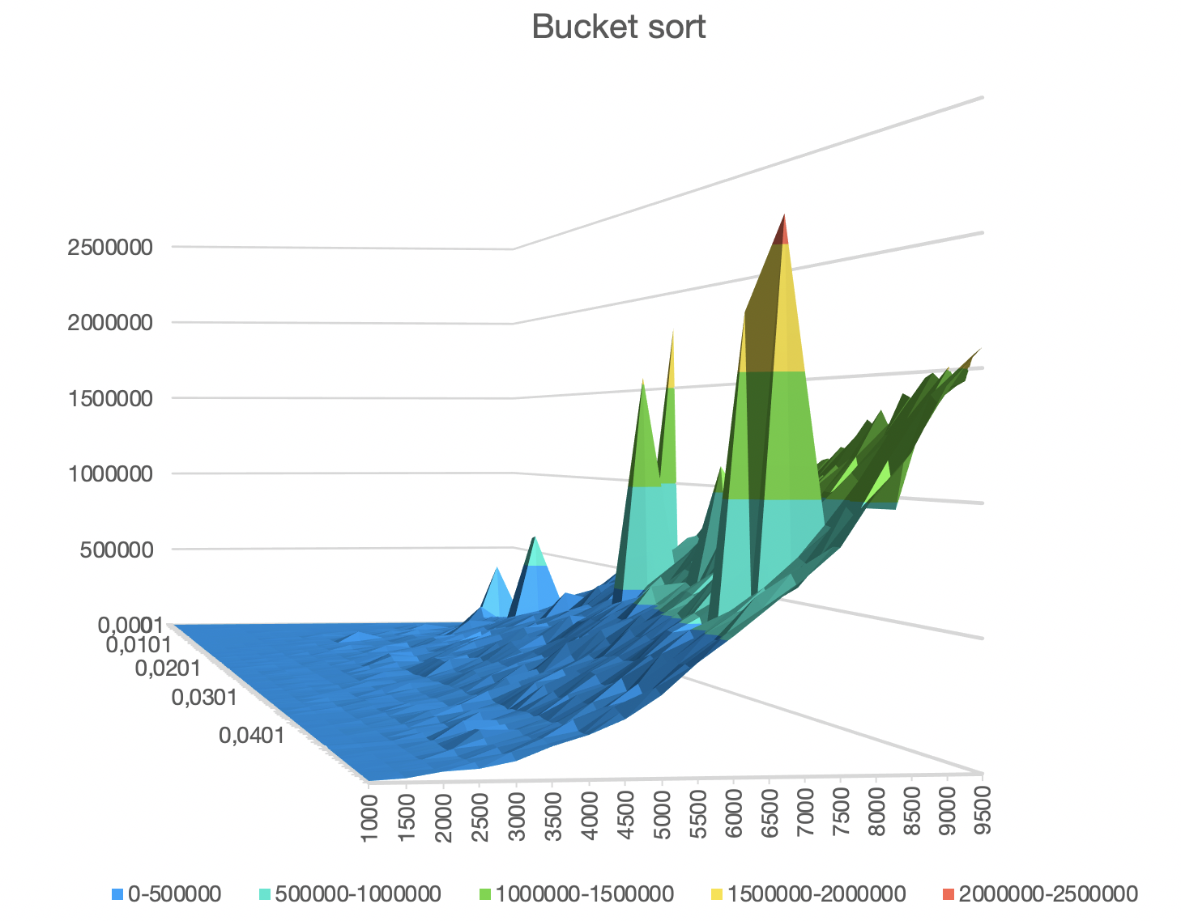

**2. std::sort**

Complexity

On average, linearithmic in the distance between first and last: Performs approximately N*log2(N) (where N is this distance) comparisons of elements, and up to that many element swaps (or moves).

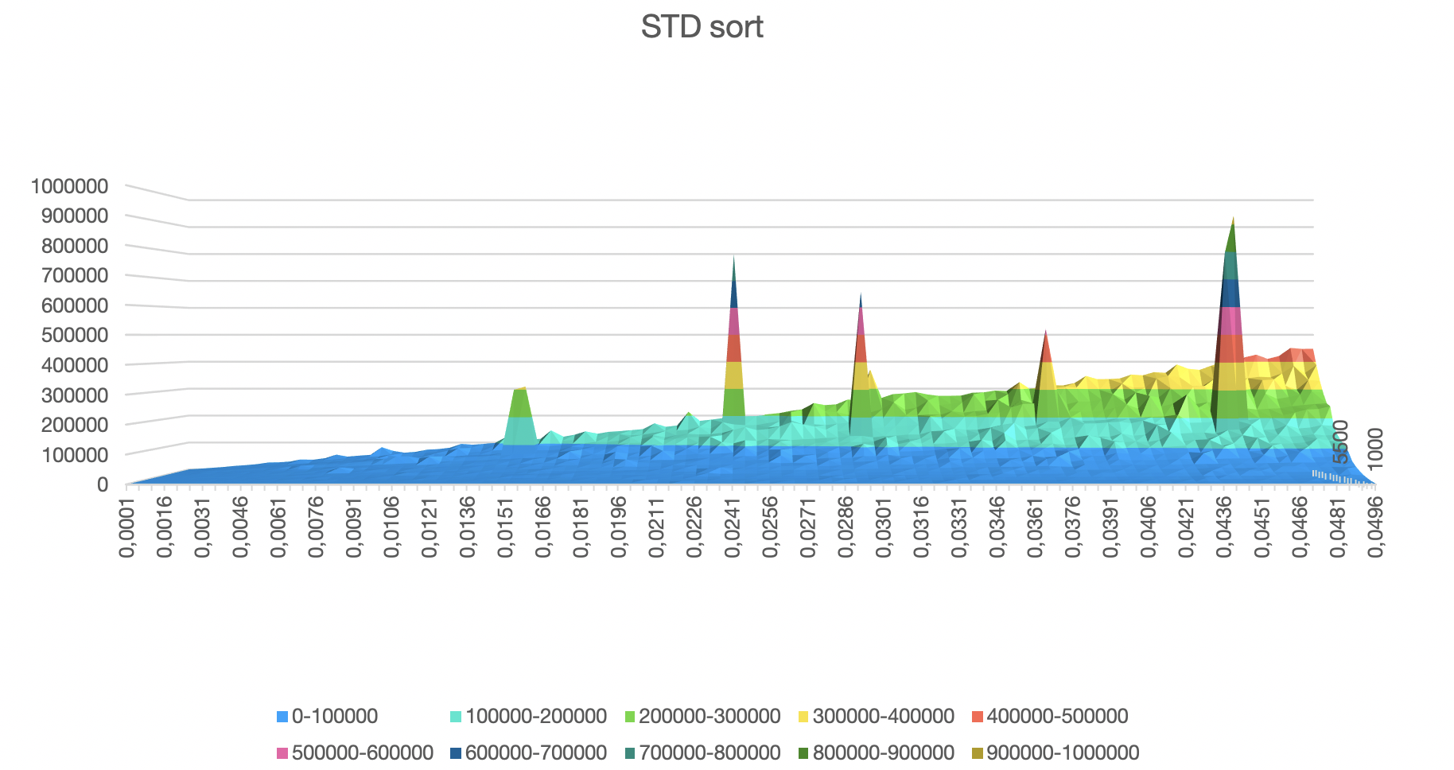

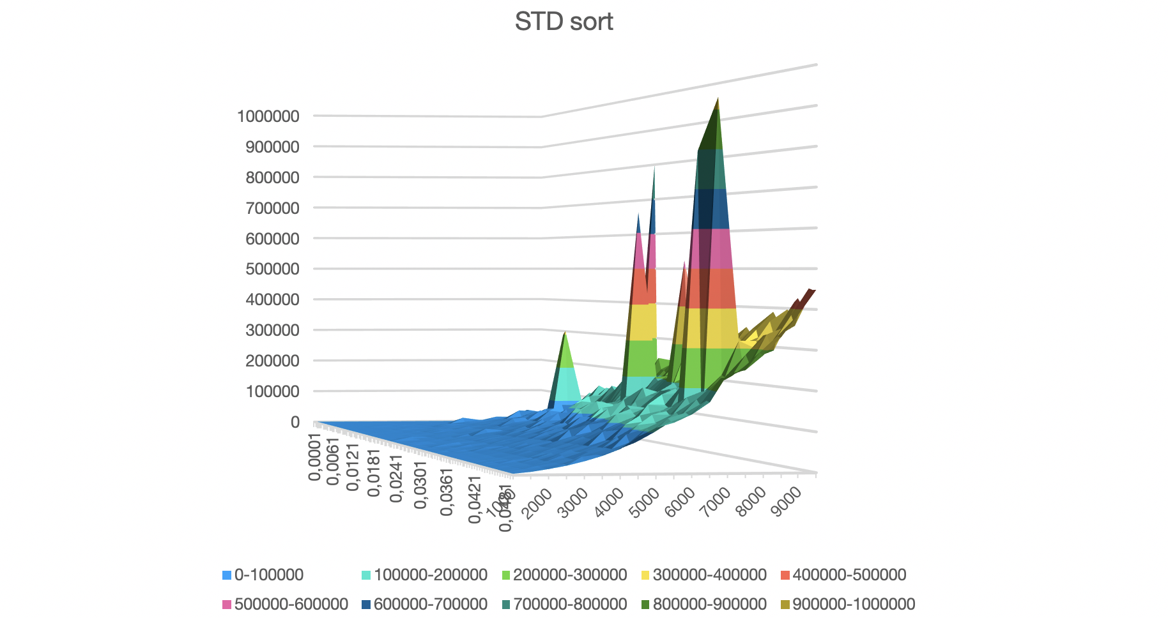

**3. Radix sort**

The idea of our Radix Sort implementation is to do 4 bits by 4 bits sort starting from least significant digits to most significant digits(this version demonstrates the best results). Radix sort uses counting sort as a subroutine to sort.

Expected complexity O(E)

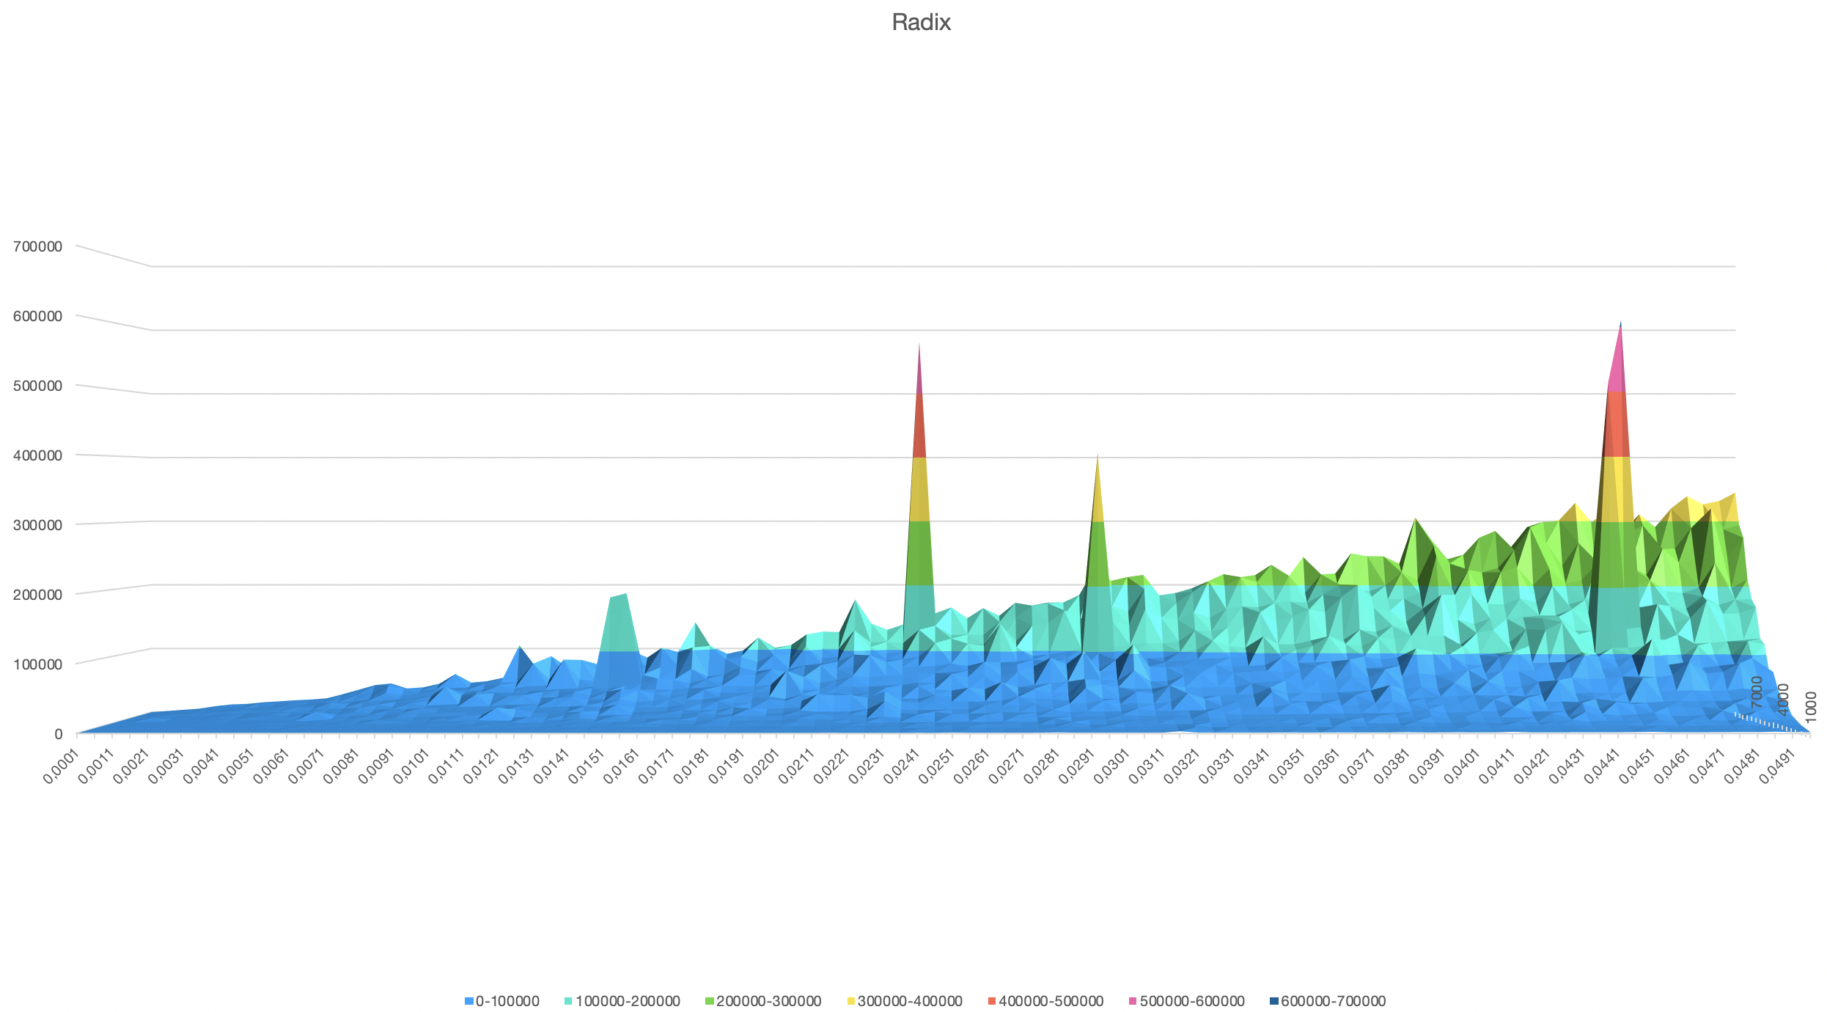

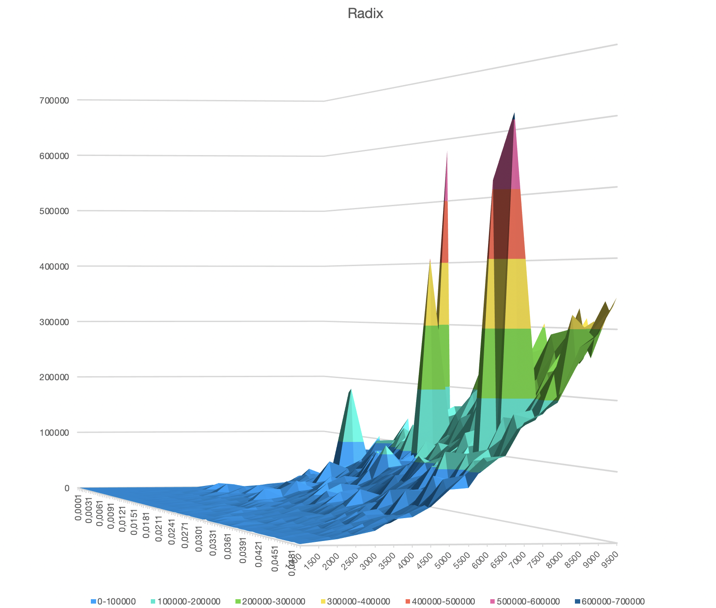

**Sorts comparison**

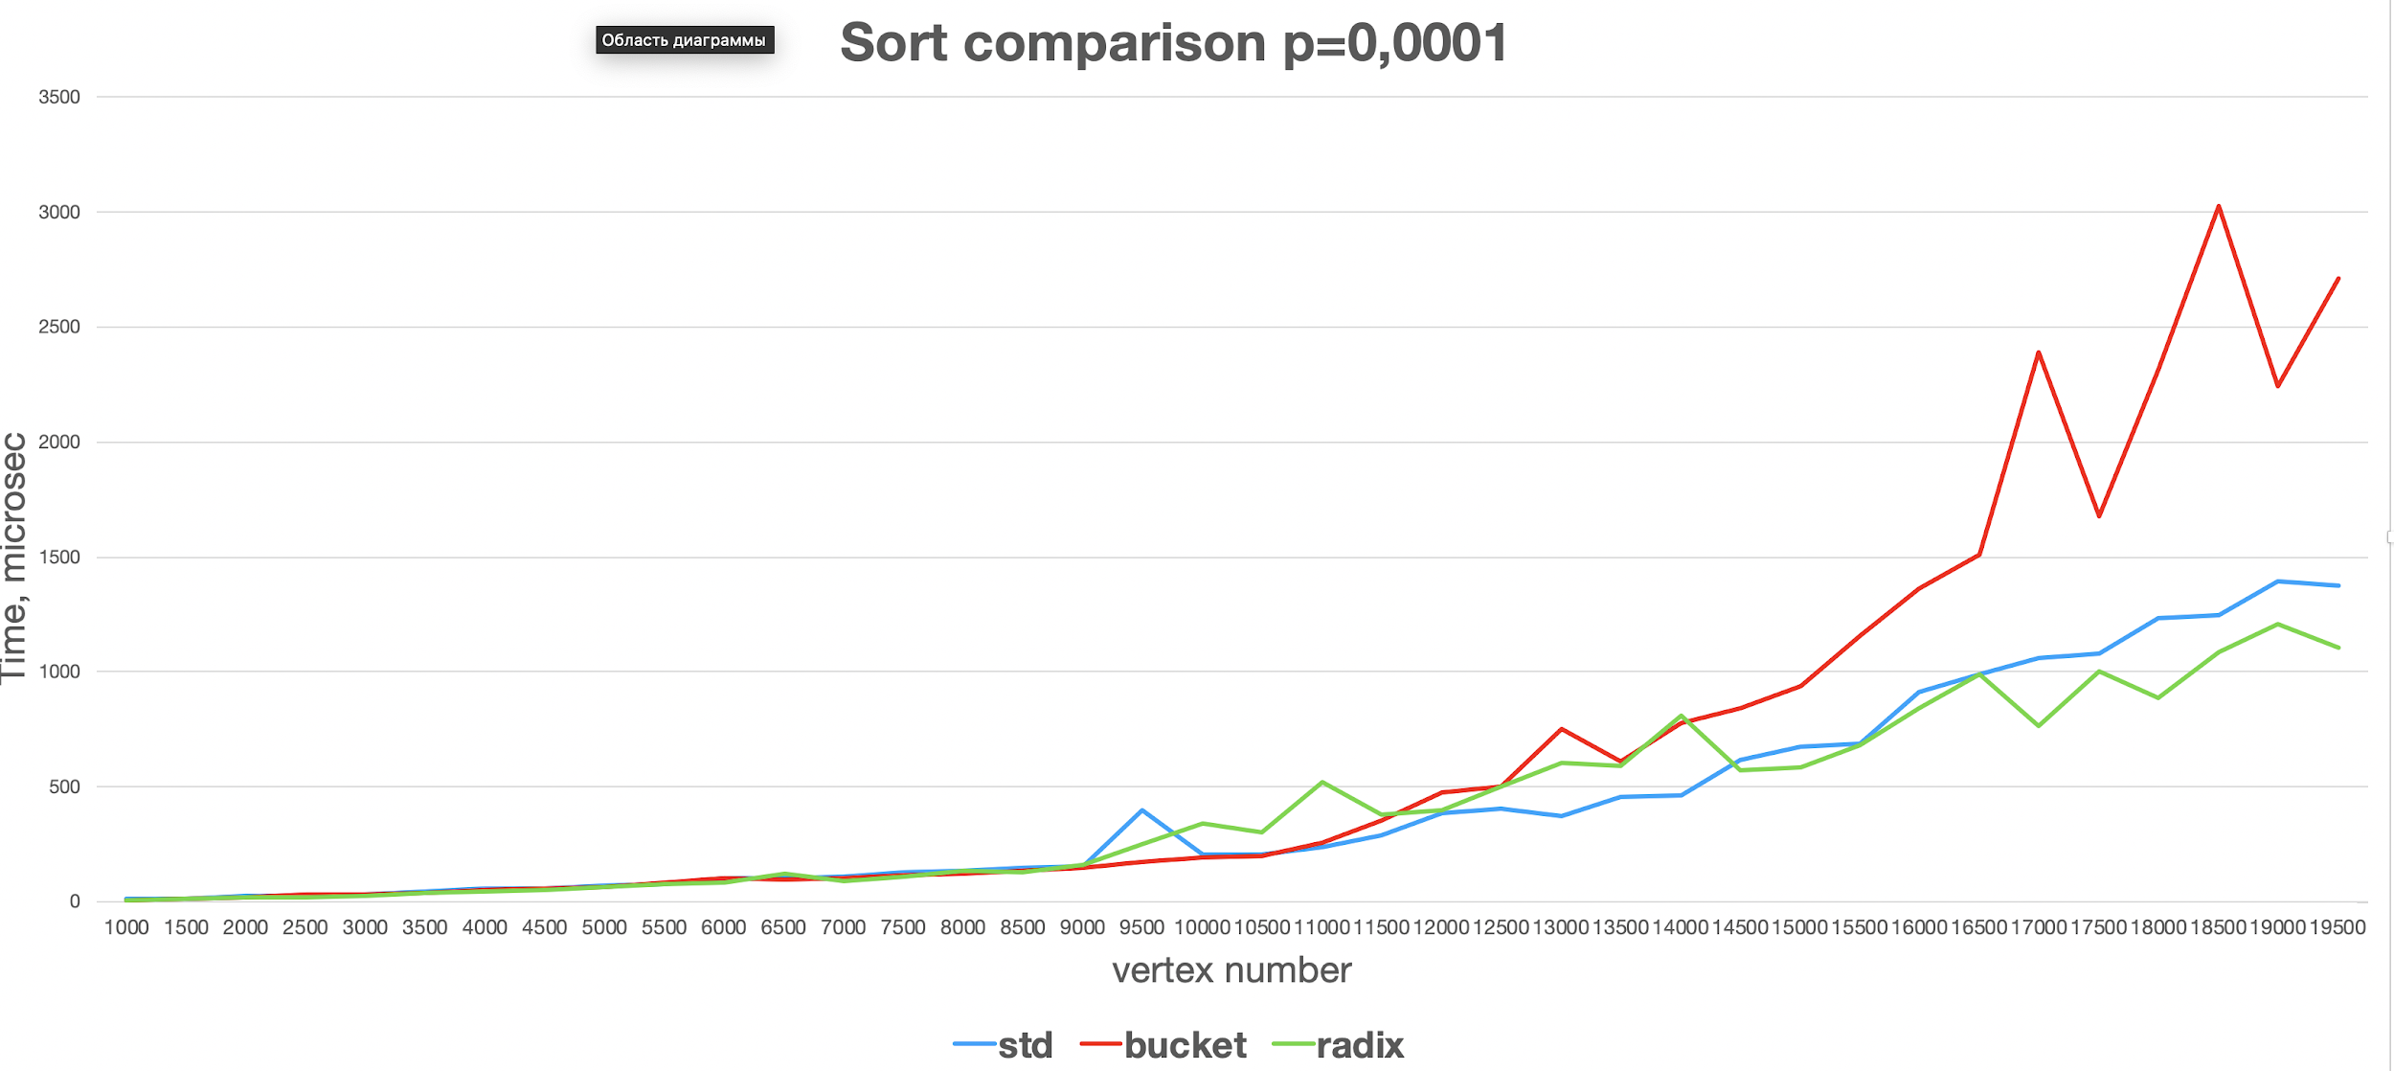

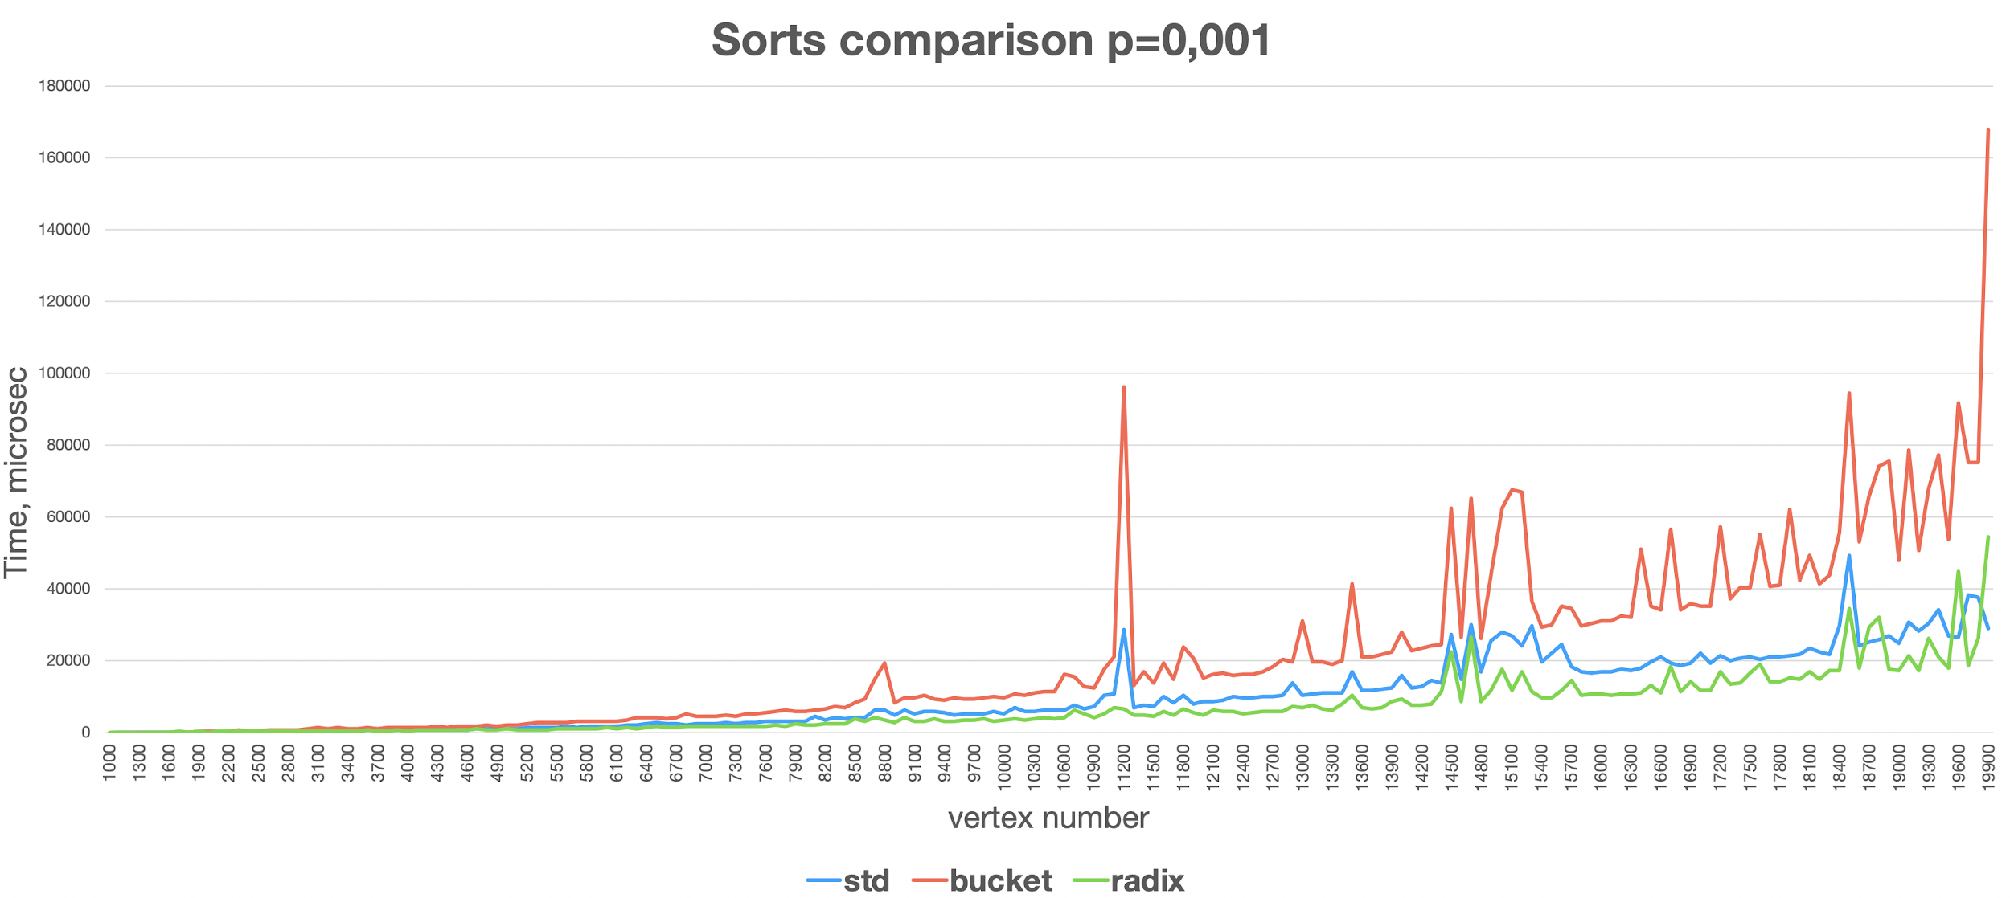

**Radix sort with radix size 16 (4 bits) is the fastest.**

**Real graphs tests**

Source: <http://networkrepository.com>

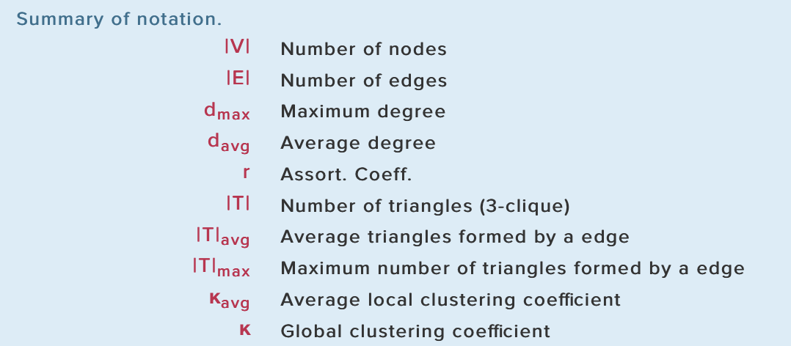

1. Citations graph http://networkrepository.com/cit-DBLP.php

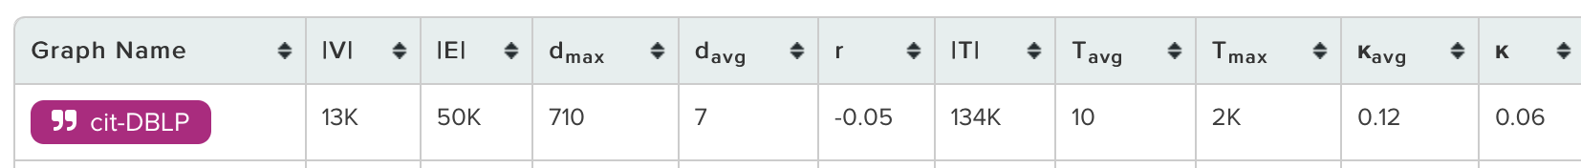

Results:

randomized bridges 0.0274495 seconds

randomized two bridges with std sort 0.0310553 seconds

randomized two bridges with radix sort **0.0300858** seconds

randomized two bridges with bucket sort 0.042756 seconds

number of one bridges: 4919 that is each citation from these 4919 citations was provided by only one article.

number of two bridges: 157. Small number characterise a small probability of citate only by two articles.

1. Road http://networkrepository.com/road-luxembourg-osm.php



randomized bridges 0.00317389 seconds

randomized two bridges with std sort 0.0616546 seconds

randomized two bridges with radix sort **0.0399916** seconds

randomized two bridges with bucket sort **0.0445509** seconds

number of one bridges: 23076 that is 23076 road sections are the unique path between some regions of road map. If one of those paths will not be able to drive by that’s will separate these regions. That number is ⅙ to all regions number that is ⅙ probability that someone can not go to the destination point in case of some road section has been broken.

number of two bridges: 1291894 that is a great number. so it is not profitable to make a lot of roads from one point to other one, if there is already exist two general paths to it.

1. Facebook <http://networkrepository.com/socfb-Dartmouth6.php>

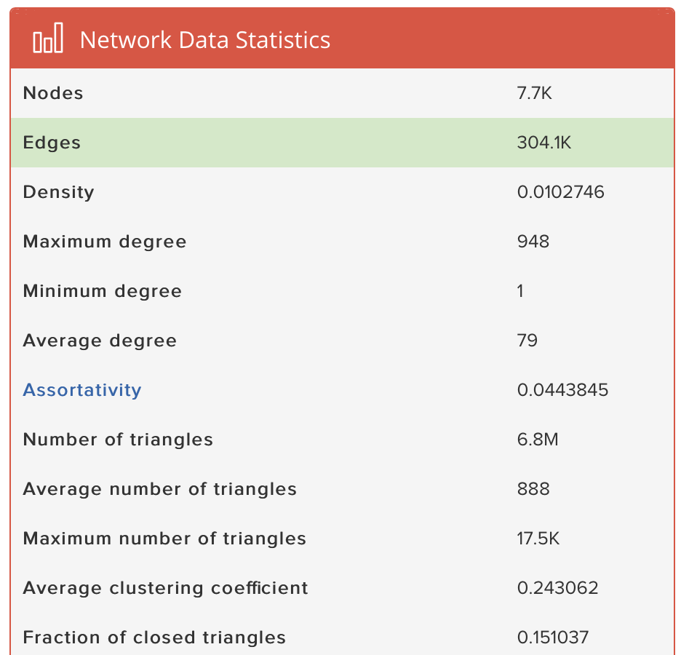

randomized bridges 0.0630237 seconds

randomized two bridges with std sort 0.122932 seconds

randomized two bridges with radix sort **0.0987708** seconds

randomized two bridges with bucket sort 0.165401 seconds

number of one bridges: 318 a small number because such social networks graphs satisfy the small world property and in real life it is rare case than only one more is point of intersection of two societies.

1. WEB http://networkrepository.com/web-NotreDame.php

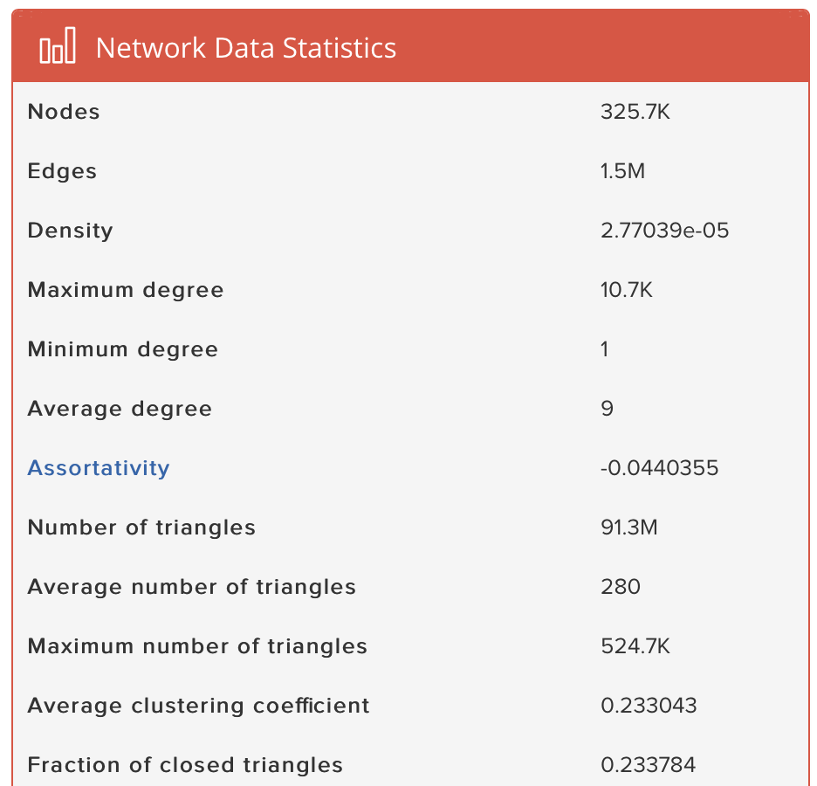

randomized bridges 0.0703822 seconds

randomized two bridges with std sort 0.151913 seconds

randomized two bridges with radix sort **0.125755** seconds

randomized two bridges with bucket sort 0.490435 seconds

number of one bridges: 165304 that is 165k of references on side sites are found or something like advertisement.

number of two bridges: 5346 more rare case than two links connect two areas of internet.

1. Social network http://networkrepository.com/soc-loc-brightkite.php

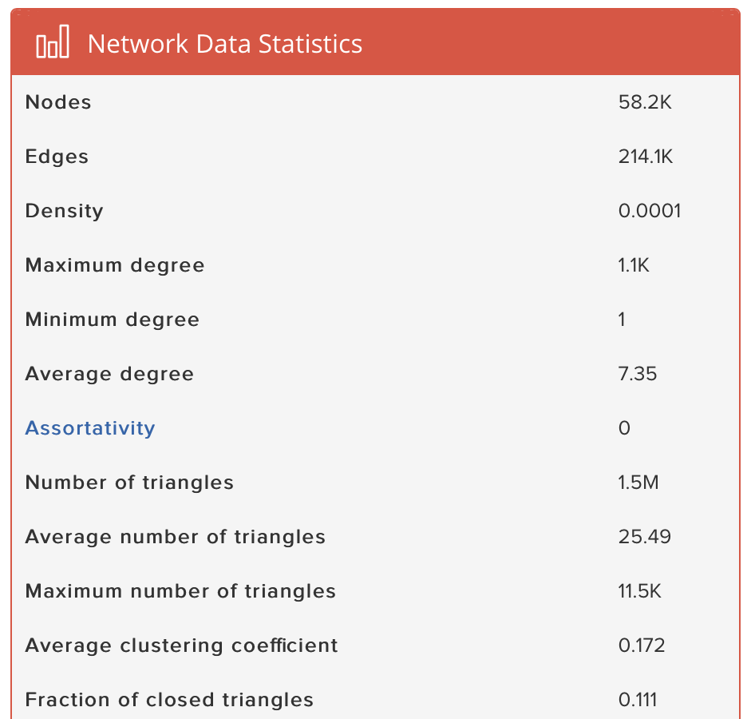

randomized bridges 0.0331494 seconds

randomized two bridges with std sort 0.0332143 seconds

randomized two bridges with radix sort  **0.0275252** seconds

randomized two bridges with bucket sort 0.0595111 seconds

1. Twitter 600 millions of nodes and 2600 millions of edges. Result: did not fit in memory.
2. USA road graph dataset 24 millions of nodes and 56 millions of edges. Result: stack overflow because dfs was implemented via recursion and stack of called functions is overflowed.